

Canoe Racing New Zealand
National Official - Manual

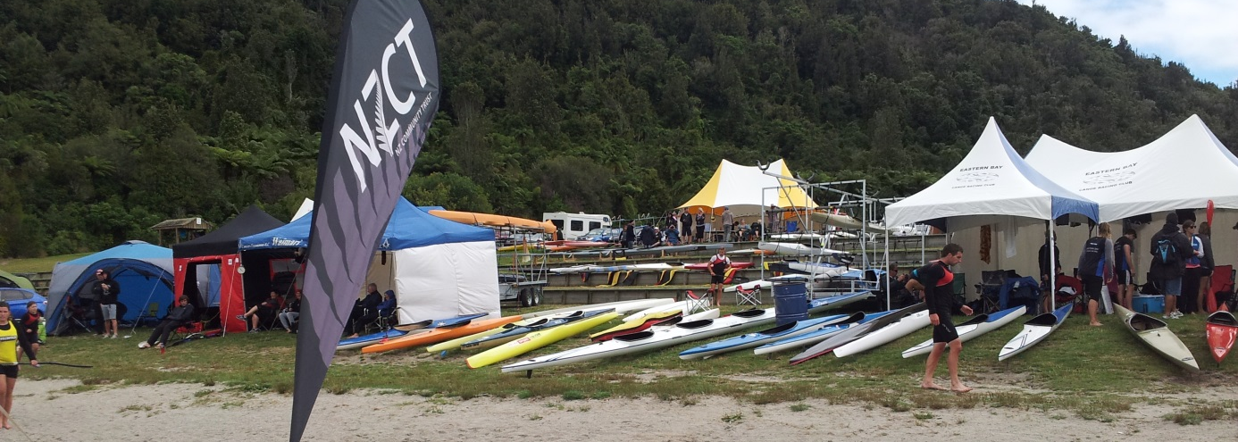
CONTENTS

Introduction
- Official Pathway
- Role of the Official
- Official Responsibilities
- Athlete centered approach
- Regatta Operations
- Official Roles

Regatta Areas
- Boat Control
- Race Control
- Start and Umpire
- Finish and Results
- Race Committee
- Rules
- Next Steps
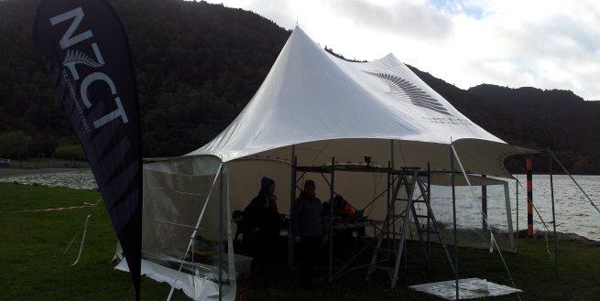
Welcome to CRNZ National Official
This course is designed to help you get started with your role as an Official and understand how the role works to make the events safe, fair and fun for the athletes.
This manual works alongside the Official workbook to help you gain this qualification. The information contained here will help you to complete the workbook.
Enjoy the training - the role of the official can be a very rewarding and enjoyable experience.

Being an Official
There are many elements that make a good event and ensure that racing is a good experience for the athletes and spectators. Officials are an important cog in the wheel and by doing their job well will help make this happen.
A good sport official is a part of a team that ensures the competitions are run by the rules but has the flexibility to adapt these to the situation as required.
The official’s role is all about helping all athletes achieve their best on the water and this should be foremost in the official’s mind.
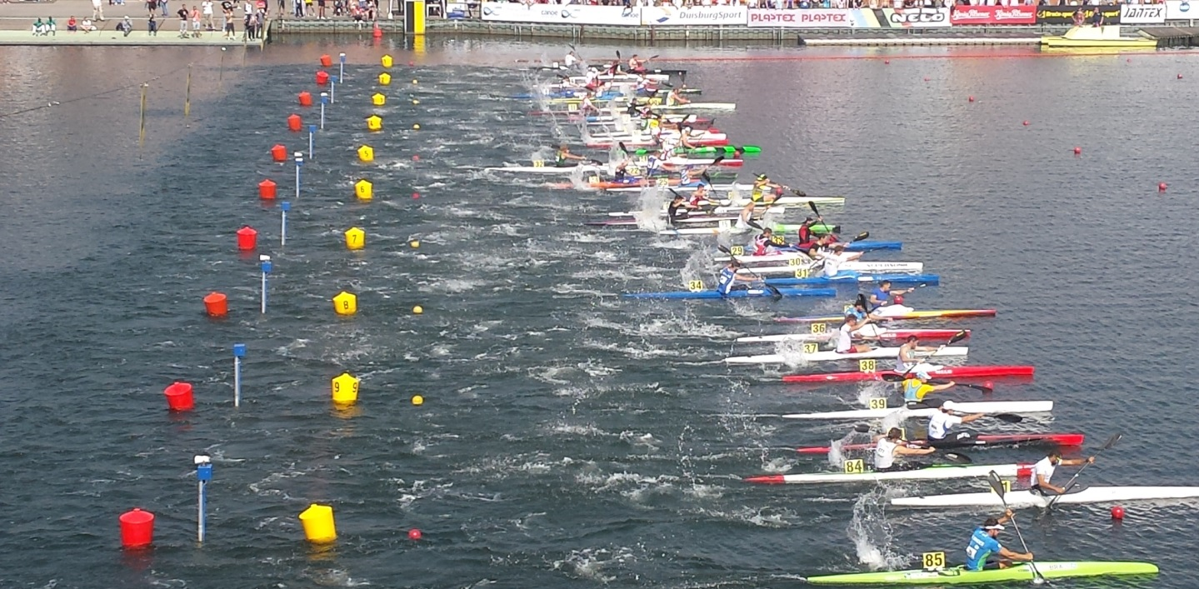
The role of an official can be a very rewarding one and the pathway can lead to national and international postings. Best of luck with your future as a Canoe Sprint Official.

Officials Pathway
Below is the pathway for New Zealand Officials.

The Role of the Official

The athletes work very hard to compete well, as an official our job is to give them the best opportunity to race as well as they can. Most decisions that need to be made are straight forward, common sense decisions that are within the guidelines of the competition rule book. Our job is not to find way to disqualify competitors but to ensure everyone is given a fair opportunity to race as well as they can.

Key attributes of a good Official
The sport of canoeing is changing all the time, officials need to keep up with developments.
Teamwork is essential for officials and being able to communicate well and cooperate with other officials, coaches, athletes and parents is vital.
An official needs to know the basic rules and where to find clarification of some of the more detailed rules if necessary.
Officials need to know how to use the equipment, tools and methods for officiating.
Understanding the nature of competition and the equipment, devices and accessories athletes use is an advantage for an official.
Good nature, sense of humour and plenty of common sense will help in almost every situation.

Officials Responsibilities

- A good sport official, is any person who ensures the competitions are run by the rules
- A good official is also someone, who can be put in a position of authority and handle responsibility without being overbearing.
- Place the safety of your athletes above all else
- Be impartial, consistent and objective when making decisions
- Accept responsibility for your decisions
- Condemn unsporting behaviors
- Always respect the rights and dignity of all the people involved (athletes, parents, coaches and other officials)
- Be a good role model
- Have a love and passion for the sport
- Maintain the motivation to perform the role well
And Always Remember:
“At the end of the day it is all about the Athletes”.

- A sport official must be able to:
  - Encourage good sportsmanship
  - Promote safety
  - Understand fairness
  - Be able to perform their role in a positive manner
- As an official you are expected to be:
  - Responsible (take your role seriously)
  - Trustworthy
  - Honest and impartial
  - Prepared and competent
Communications Skills

At times the athletes and coaches (and parents) will take the competition very seriously. Sometimes places on national teams and squads will be based on an athlete’s performance at an event. This can get very tense for these individuals and their communication is not always as friendly as it should be. An official should be aware of this and not take these conversations personally and keep their own communication above the line.
Things to be aware of:
- Set the tone of the conversation to the situation - be assertive when required but most of the time this will not be required.
- Set and maintain a standard communication protocol between officials in different areas (e.g. between start and finish)
- Don’t over communicate, stick to the point and keep to the facts (especially over the radio).
Other prerequisites to be a good official (and not often listed) include:
- A sense of humor, thick skin and a 20/20 vision
- The capacity to not criticise but to be criticised
- An understanding that you are not always right and being able to correct mistakes
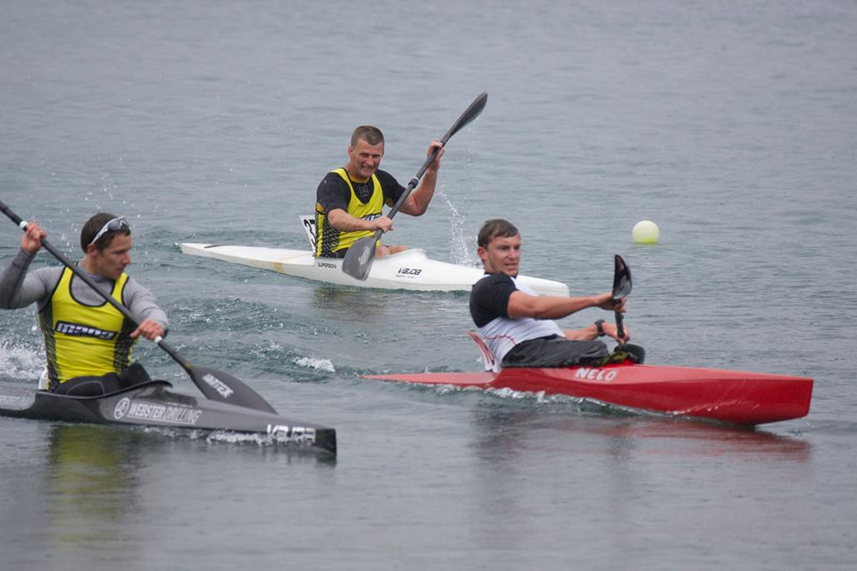

Safety and Risk Management
Officials have a duty to take reasonable care to avoid injury to participants and others at the regatta including themselves. This includes keeping up to date on the rules of the competition, particularly rules relating to safety. Officials also need to be aware of managing their activities to ensure they remain safe during and travelling to and from the regattas.
Risk management tips for keeping participants safe:
- Follow and implement Health and Safety plans for the event.
- Always inspect and clear the regatta arena of visible dangers. Consider altering the course if there are hazards.
- Cancel the event if there is inclement or dangerous weather (e.g. extreme heat or thunder storms where lightning is likely).
- Inspect and control use of both competition and safety equipment.
- Enforce the rules of the sport.
- Keep a record of any incidents that occur during a competition.
- We spend long days at the regatta. As an official, you need to ensure you look after yourself by dressing for the conditions, wearing sunscreen if appropriate and staying hydrated.
- Use common sense and be proactive in managing hazards.
- Ensure you know the safety procedures on the water and where the safety boat and first aid are stationed and how to contact them.
Factors in keeping yourself safe:
Officials can work very long days, sometimes with short breaks.
- Ensure you eat and keep hydrated throughout the day.
- Wear appropriate clothing for the conditions and wear sunblock and a hat if it is hot.
- If lifting equipment, ensure that this is done safely - use a second person to help if needed.
- When using equipment make sure there is appropriate safety in place. If using the start gun wear ear protection.
- If out on the water, ensure lifejackets are worn.
- When driving to and from the regattas ensure you get appropriate rest and stop if tired.

Regatta Operations – Pre Regatta

Prior to the event starting there is a lot of work that needs to be done to ensure everything is ready for the participants. This organization starts months in advance
Information
Information must be sent to the clubs and officials to let everyone know when, where and the events in the regatta.
Book Venues and Equipment
Bookings need to be made up to a year out to secure the venue and there is a lot of equipment that needs to be bought in or checked before the start of the regatta.
Entries and draws
Ensure there is a good process for entries and develop lane draws for each race. Communicate this well with team managers and officials.
Arrange Volunteers and look after them
Work out what help is needed and find the people that can help. Look after all volunteers, they are doing this out of the goodness of their hearts. They will need to know what to do and when, and they need to be fed and watered. They will also need the tools to do their jobs properly.
Safety
Always deliver a safe environment – that should always be on the top of your check list. Check the environment, equipment and weather. Have a good safety plan with the right people involved to provide safety services.
Plan B
Things go wrong sometimes - try to be aware of the risks and have a plan to manage these.
Good planning will go a long way to ensuring a top quality regatta.

Regatta Operations - The Course
The basic layout of a course is pictured. Details of the race course are set out in the Competition Rules manual.
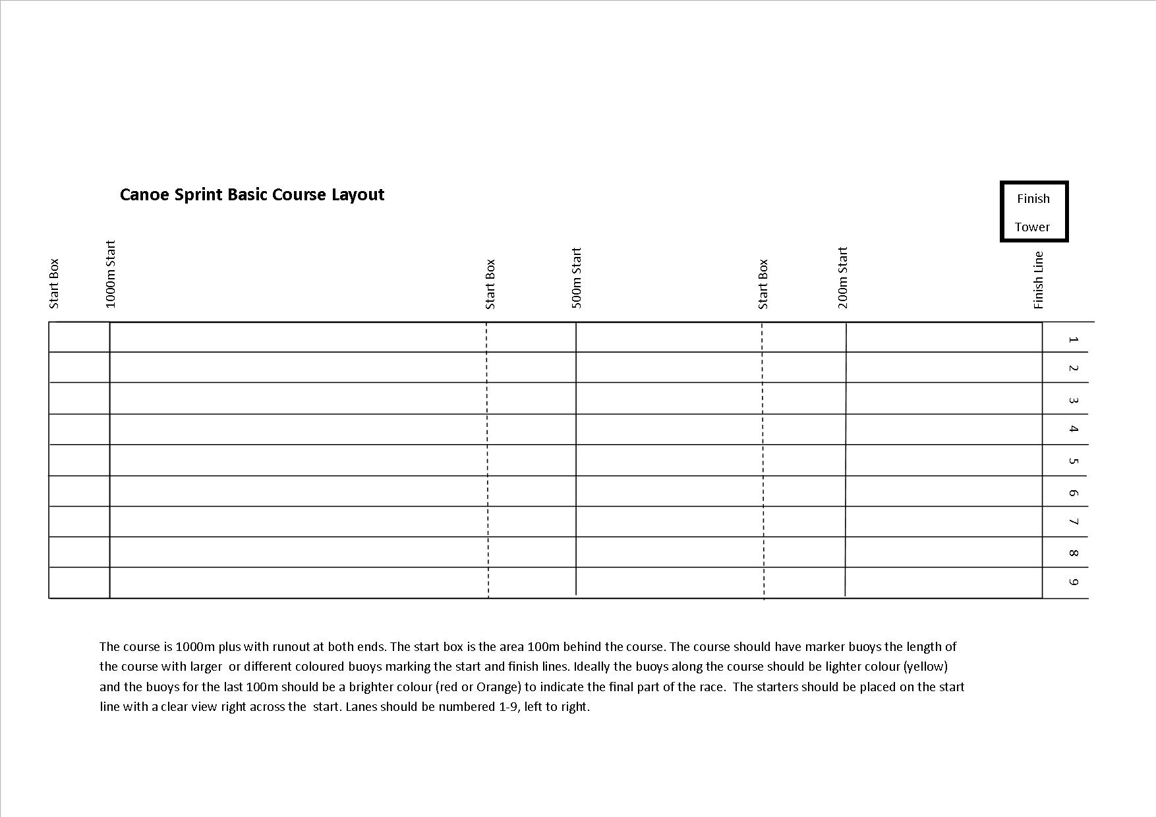
Officials Roles at regattas

There are a number of roles required to run a regatta. A brief description of each of these positions is in the CRNZ competition rule manual.
- Chief Official
- Deputy Chief Official
- Competition Manager
- Chief Finish-line Judge
- Finish-line Officials
- Starter(s)
- Boat Controllers
- Race Control Officials
- Results Officials
- Announcer
- (Aligners, Course Umpires, Turning point Umpires may be used if circumstances permit).
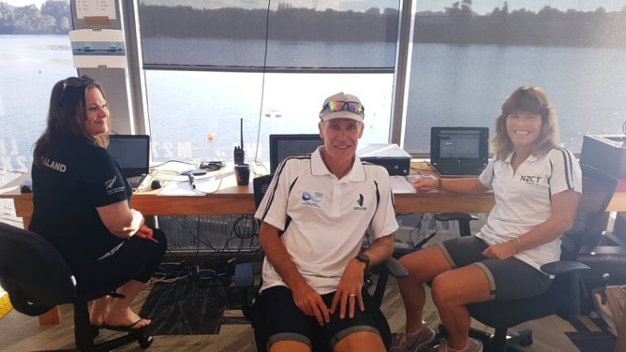
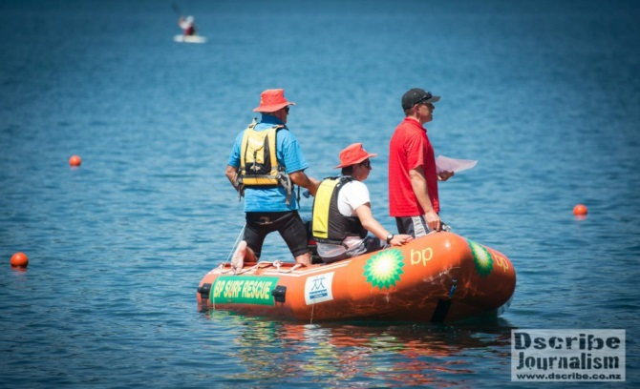
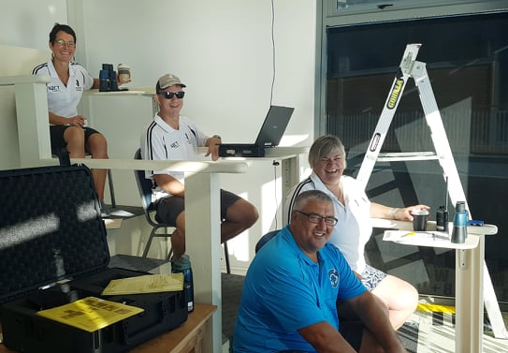
Boat Control
The role of Boat Control is to ensure that all boats used for racing meet the racing standards as set out in the competition rule manual. Usually there are 3-4 boats dried and weighed in each race immediately after the boats finish racing.
At boat control officials will need to check:
- The weight of each boat
- The length of each boat
- Boats are in a safe condition
- All parts of the boat are convex
- No devices are on the boat that have the ability to give real time feedback to the athlete while racing.
- That there are no foreign substances on the hull of the boats.
- That weed control has been completed where required.
Usually in finals the first 4 boats will be weighed and in the heats there will be 3 boats chosen randomly for weighing.
Boat weights and lengths:
Boat | Min. Weight | Max. Length
K1 | 12kg | 5.2m
K2 | 18kg | 6.5m
K4 | 30kg | 11.0m
C1 | 14kg | 5.2m
C2 | 20kg | 6.5m
C4 | 30kg | 9.0m
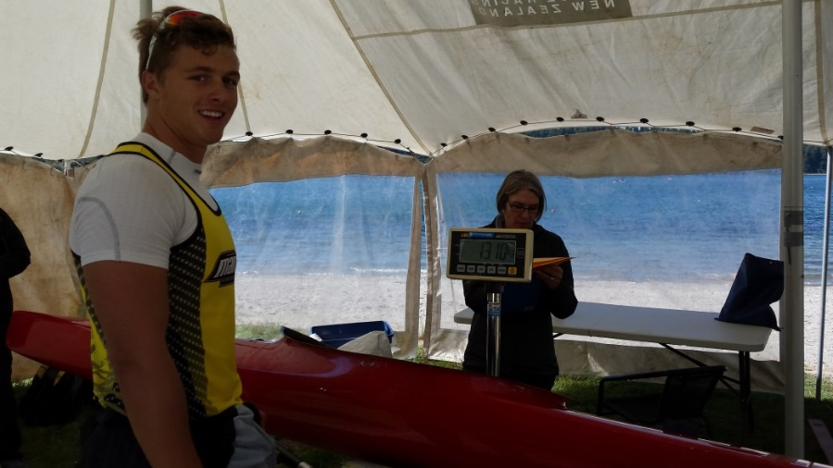
Race Control

Race control is used to manage the boats going onto the water for both safety and the smooth running of the event. Officials in this area will ensure all boats and paddlers are checked for compliance, they have their number and if conditions are adverse can be held back to ensure safety.
Specific duties
- Hand out boat numbers
- Check all competitors arrive on time and report any missing paddlers to start
- Check boat and paddler compliance including weed control.
- Check all 14 and under paddlers are correctly wearing PFDs
- Report any problems to start and race control (late boats, boat change overs)
- Check paddlers are wearing the correct uniform.
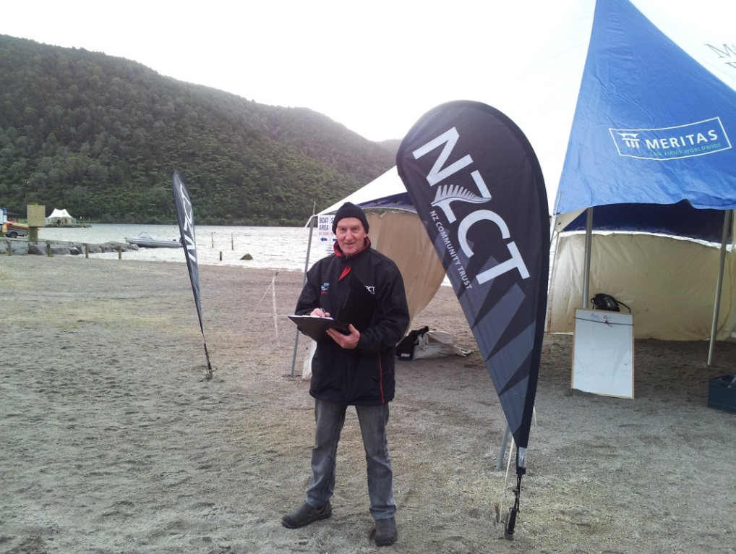
- Hold competitors at the beach if conditions are not safe for these paddlers.

Note: At international regattas this area is referred to as Polyox/ID Control
Starter and Umpires

The starter controls everything that happens at the start and in turn this controls the timing of the regatta. If the starters are late it will be very hard to make up the time. The start is all about getting the paddlers away in the fairest possible manner. Without start gates this is a very hard job to get all paddlers lined up in a completely straight line with no movement.
Start procedure:
- 5mins prior to start call the athletes into the start box and read out the list of starters.
- Give a 4, 3, 2 & 1 minute warning call
- Ensure the finish line is ready for the next race and make sure all of your equipment is ready & working properly including the start gun.
- Bring the paddlers up to the line and get them to remain stationary. You will need to bring paddlers back and forward to maintain a perfect line.
- Carry out the start commands “Ready” “Set” “Go” or loud noise (i.e. gun).
- Check for any paddlers breaking or moving forward before the start.
- If a paddler false starts fire a second shot and call “Stop, Stop, Stop”
- Call out the person that false starts and warn the group that a second false start will result in a disqualification. Let the finish line know who false started.
- Remember, at our domestic regattas anyone who false starts on the second or subsequent starts will be disqualified, regardless of whether they were the first false-start or not.
- Realign the boats and repeat the start.
- Record any details of the race on the start sheet (False starts, DQ, missing paddlers/numbers, any issues.
- The umpire boat checks that paddlers paddle the race in their lane to avoid wash riding or impeding other paddlers.
Umpires procedure:
- Umpires will follow the paddlers down the course staying behind the last paddler.
- Lanes are 9m wide and paddlers must remain in the middle 5m for the duration of the race.
- If a paddler moves out of their centre 5m for more than 50m the umpire must raise a red flag report this to the Chief Official. If all clear they will raise a white flag.
- If a paddler leaves their leaves their lane for a prolonged period this must be reported to the Chief Official.
Please note: due to resourcing at NZ regattas we seldom use course umpires. We rely on officials in the start and on the finish line to watch for paddlers leaving their lane of wash riding.
We also take a more relaxed approach for younger paddlers and during tough weather conditions but this must be reported to the Chief Official to make the call on any disqualification.
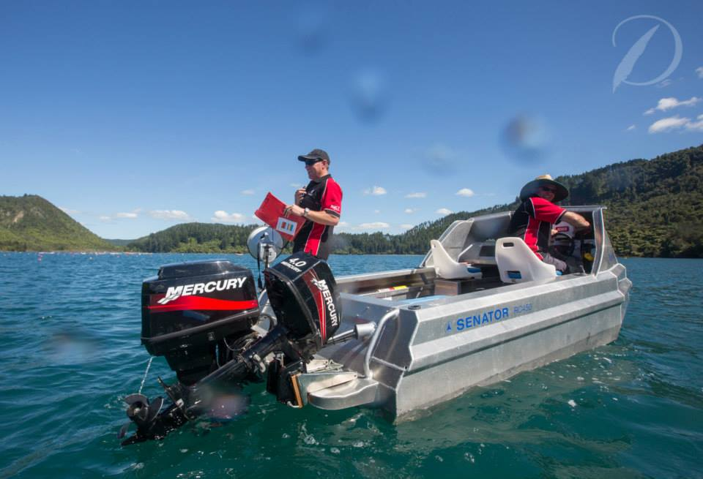
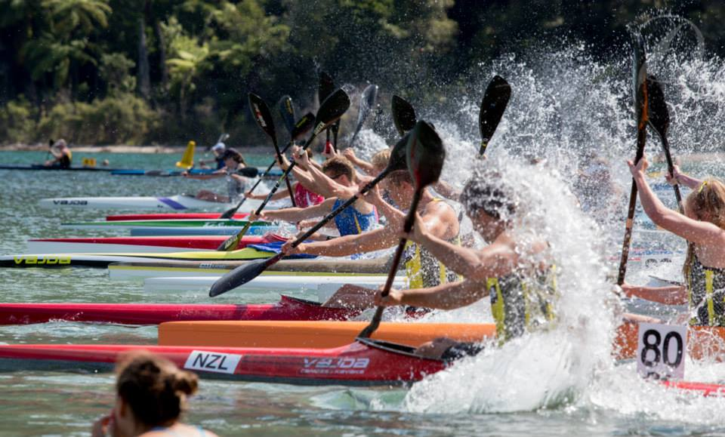
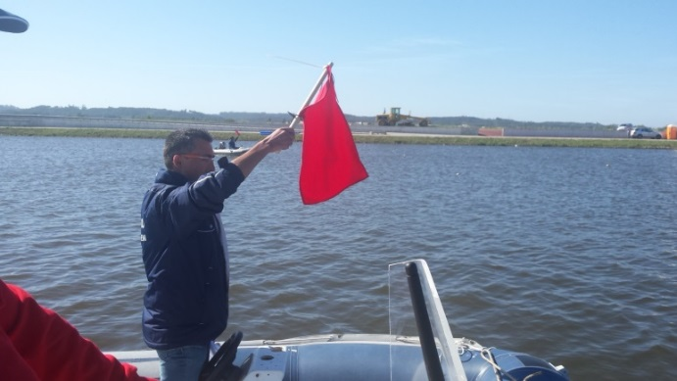
Finish & Results

The finish line is operated by a team that records the finish order of each race and processes the results. A finish line camera is used to record the finish of the race and a specialised programme will record the race time for each paddler. We also use a back-up system that manually records the finish order in case there are problems with the video finish.
Finish line positions
- Video Capture – initiates timing system and records the end of each race.
- Video Analysis – records the finish position of each boat to give race times and order.
- Results – takes the final results and develop progressions and pushes final results to the web.
- Finish Judges (3) – visually determine and record the order of finishes as a back-up.
- The finish team prepares the results for medal presentations and the announcer.
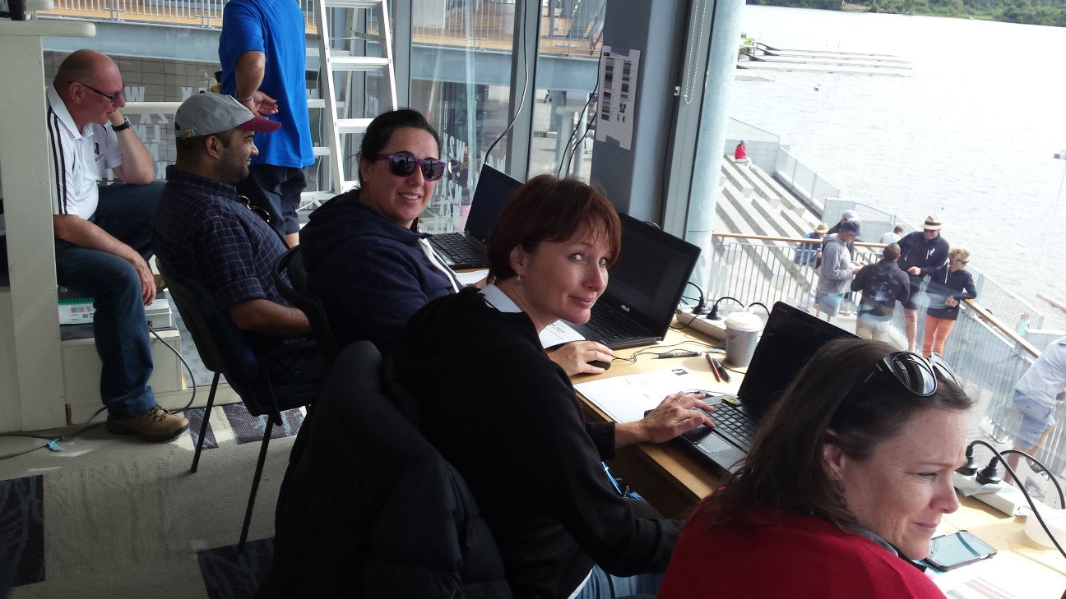
The team on the finish line have to be very focused and ensure the results are 100% accurate. There are many time pressures on this team to ensure progressions are ready for future rounds and presentations.
Competition Committee
The competition committee is made up of the Chief Official, Deputy Chief Official and Competition Manager who together make any decisions that go beyond the normal conditions. The Chief Official will run the team managers meetings prior to the event and any that are required during the running of the regatta.
Specific areas that the CC look at:
- Warnings, DQ & Protests.
- Programme changes
- Safety interventions or controls
- Rule or course changes
- Allowances for special circumstances.
At our regattas the Deputy Chief Official and Competition Manager have roles that are stationed at other positions. The Chief Official (CO) does not generally have any other specific role. This enables them to deal with any questions or issues that arise.
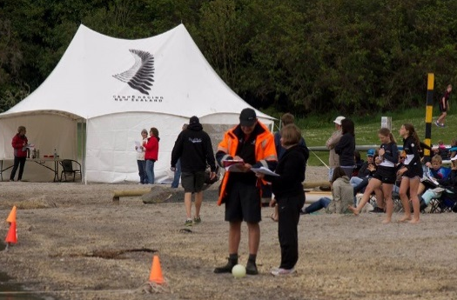
The Team Managers must direct all major communications through the CO and that person also runs the Team Managers meeting. The Chief Official is the only person able to disqualify a competitor aside from false starts where the starter has the authority to disqualify a competitor. The CO will make disqualification decisions based on some or all of the following:
- Report from the official in the area concerned
- Further investigations
- Discussions with the Competition Committee
- Discussions with the Team Manager and/or athlete concerned
Team Managers Meeting
The team managers meeting is held the night before the regatta begins. The topics discusses at the meeting are:
- Outline of the regatta site and course layout
- Any rule clarifications
- Programme changes
- Scratching’s and team boat changes/finalisations
- Questions from team managers
Rules
An important aspect of being an official is making sure you know the rules. You don’t need to have all of these stored in your head but must know where to find these. If you are not sure about something please ask. A copy of CRNZ rules and Officials Duties are available on the CRNZ website.
There are many rules, but perhaps the most important rules to run any basic event are:
- Do make sure boats are safe and the correct weight. K1-12kgs, K2-18kgs minimum.
- Underweight boats will be disqualified at any National Regattas.
- If adding any extra weight, make sure it is taped in or fixed. It must not be able to fall out when the boat is turned upside down.
Starts

- Do make sure you know the rule on False Starts.
“Any competitor who makes a second false start will be disqualified from the race. The decision of the starter will be final”
- Sometimes you will come across some competitors late for their race. They are not allowed for any reason to paddle up the course. This is an automatic disqualification.
- Paddlers must not leave their lane, they may be disqualified it they impede another paddler.

Competitors must treat officials, other competitors and spectators with respect. Foul language and abusive behavior can result in a disqualification from the whole regatta.

Basics for Running Club Events

No matter how big your club event is going to be, you will need a basic set up to run it. Make sure the following are in place:
Course Layout:
- Where possible a starting and finishing point marked by buoys. Distance can be measured by GPS.
Safety:
- If possible have a safety boat always in place, or ask your senior paddlers to paddle along the race in a stable boat to keep an eye on other paddlers. Especially the young or inexperienced ones.
- Make sure the racing area is safe and always check weather conditions
- Junior and inexperienced beginner paddlers should wear a life jacket at all times.
- Design an easy access safety area, for emergency services, such as: Ambulances, Fire Service, Police
- Have a First Aid Kit and a safety officer trained in First Aid available at the club during the event.
- Make sure you do know the emergency service numbers (e.g. display them on Club notice board)
- Know your competitors, any allergies, any medical conditions, that you need to be aware of. Have a waiver form available.
Officiating at a basic club event can be run entirely with as few as 3 volunteers.

Basic Equipment

- Buoys for course layout. Where not possible use markers on the side of lake, river, trees etc.
- Stop watches, start list and notebook. Also recording system, binoculars and radio if available.
- Megaphone for starters and start gun if available.
- Scale (if boat control in place), plastic bags, sand and tape for extra weighting
- Forms (e.g. entry forms), time keeping, RAMS (Risk Assessment)
- Boat Numbers (unless you can easily recognise every paddler and their boat)
- First Aid Kit, Safety Officer, Safety Boat, Emergency contacts and Emergency service numbers.
- Finish recording and results system (This can be a computerized system for more accurate timing and results or as simple as pen and paper).

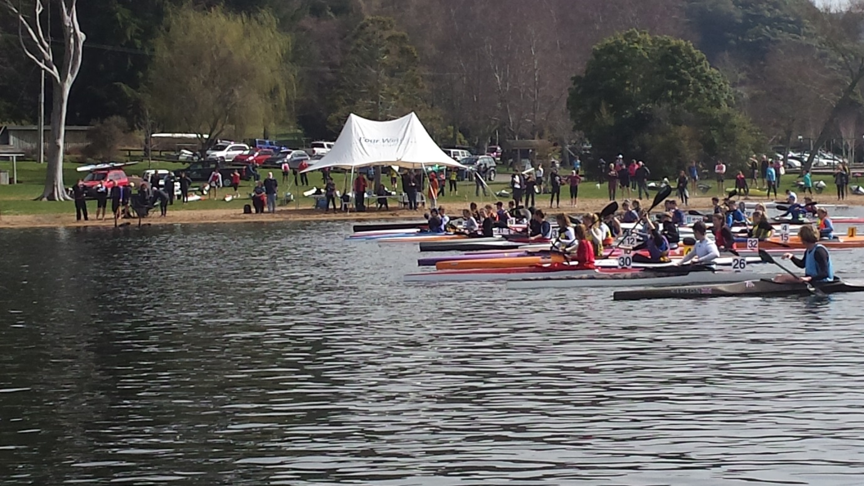
Top Tips
General
- Do make sure paddlers compete in a fair manner. If you believe paddlers have not competed in a fair manner or their behavior has been detrimental to the sport, talk to the organising committee or a senior Official in charge. They may be disciplined or disqualified.
- If you are not sure ask for clarification from an experienced Official.
- Do have fun.

Next Steps
Now that you have completed the first CRNZ module, put into practice what you have learnt.
To gain practical experience and complete your Level 1 Certificate:
Send an email to the CRNZ Business Manager, and register your interest to work as volunteer at one of CRNZ’s Regattas.
You will be working in a dynamic fun environment under supervision, and be mentored by one of our International Canoe Federation qualified officials. This opportunity will give you the chance to see the full officiating process, and further develop your knowledge and understanding of what it takes to be a Racing Official.

Contact Details:
Karen Simpson-Warren
karen.simpson@canoeracing.org.nz

