KAHAWAI

paddler.nz

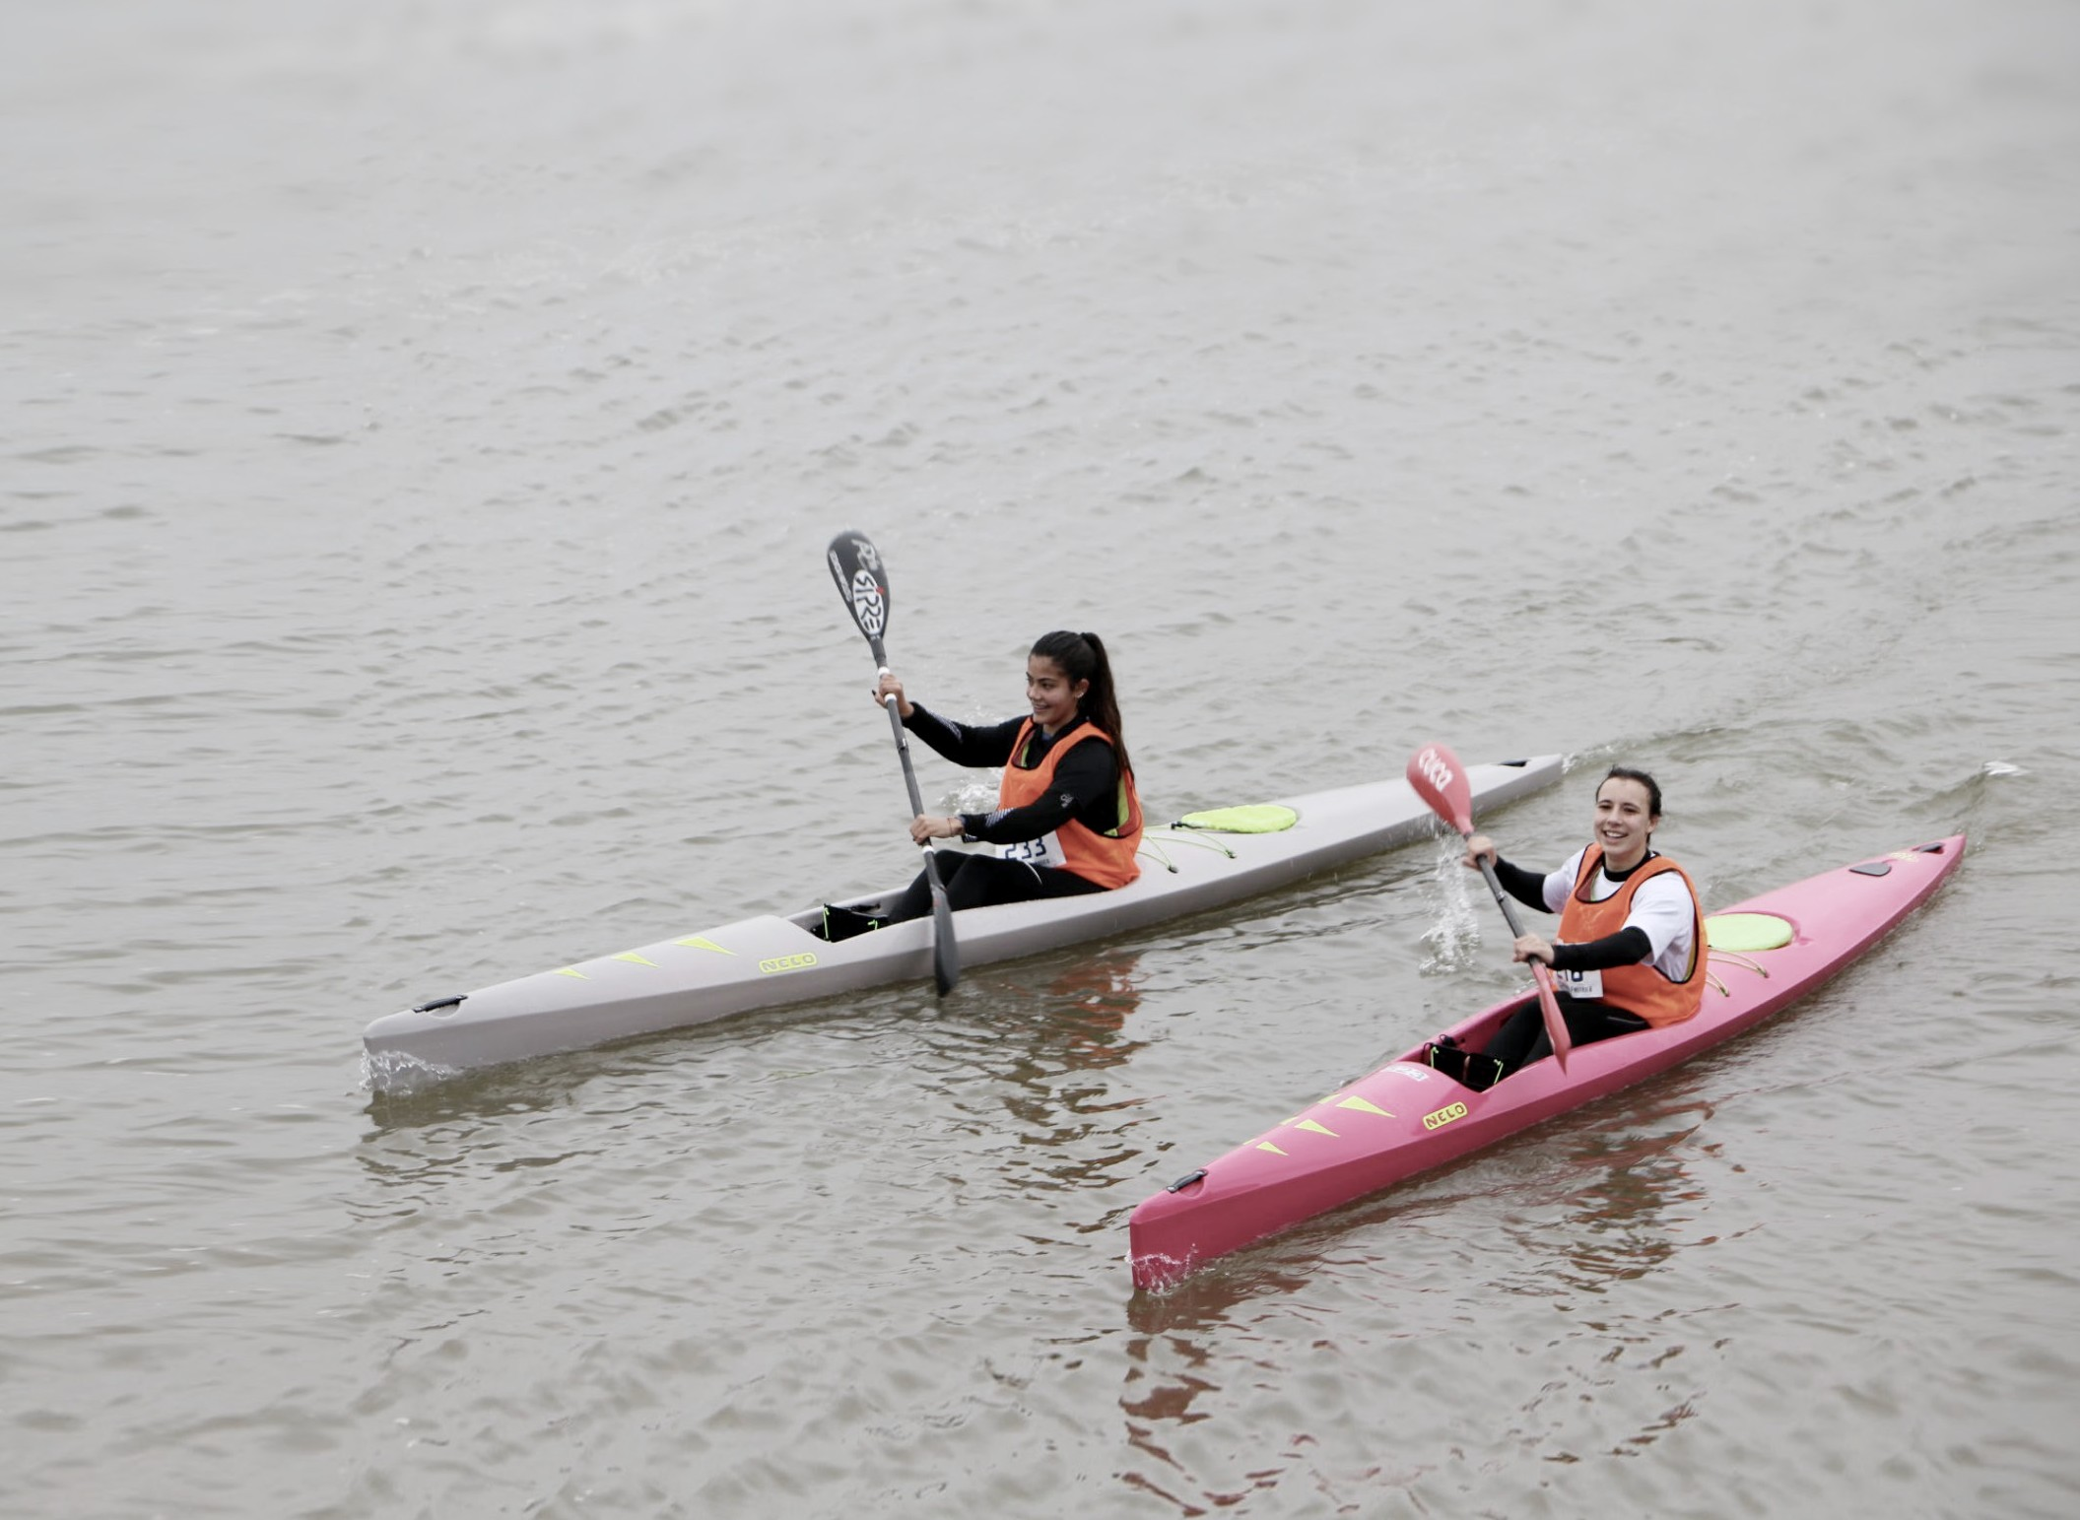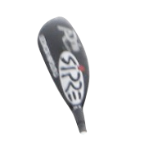
SPRINT
SURF
KYAOUHNGAPAWDDLAERI
CLASS
DOWNRIVER
+ MULTISPORT
OCEAN

KIA KAHA I TE WAI BE STRONG IN THE WATER

Introducing Kahawai, a new competition concept designed to be an enjoyable, engaging entry into paddling, and to build bridges between flatwater, ocean, surf and river paddling.
Aotearoa is a proud seafaring nation. Our oceans, rivers and lakes are central to our Kiwi identity and we share a rich history from which we all gain inspiration. More recent Kiwi icons include some of the world’s greatest
paddlers, from surf lifesaving to ocean paddling and Olympic sprint kayaking. We love to paddle, but entry into the sport is difficult – existing paddling disciplines are highly specialised and equipment is not accessible. We believe there is an opportunity to create a hub that connects paddlers with opportunities to link, learn, compete and enjoy being on the water.

Kahawai is the Māori name of an iconic native fish found all around Aotearoa’s coastline. Kahawai are renowned as being strong, active swimmers, covering vast distances quickly because of their strength and speed.
Central to the Kahawai pattern is the koru representing the mauri (life force) that flows and swirls like water to convey a sense of perpetual motion, while promoting well-being, growth and expansion. The inward curl suggests a return to ones point of origin, while the
central koru in our design symbolises the ngaru (wave). Finally the rippling curved lines (ra) invoke radiating vibrancy and the expansion of energy through the water.
These stylised symbols reflect an ancient wisdom, connecting our past to the present through the element of water (wai), with the Kahawai pattern as a whole conveying a sense of connection and flow.

Kahawai goes hand-in-hand with the Paddler Try, Learn, Explore program. Competition will take place in three formats:
Competition Formats

Paddler-X • Long distance • Sprint
Tying the three formats together is the new Five2 boat concept (see below), which allows young paddlers to race all disciplines in one boat and provides flexibility to enjoy a range of paddling conditions and learn a full range of paddling skills.

Paddler-X
Paddler-X racing can take place at a beach, river or lake. Heats of 4-12 paddlers race from a start line, around one or more buoys and back to a finish line adjacent to the start. Races can take anywhere from 2-5 minutes, and every paddler will compete in several races as they progress from heats through to division finals.
Paddler-X is designed to be exciting and spectator-friendly, whilst requiring (and developing) a full range of paddling skills. Paddlers manoeuvre in groups around buoys and ride wash, and may negotiate waves or obstacles. Because of the length of races, paddlers will be rewarded for a combination of speed, endurance, skills and technique.
The Paddler-X format can be customised based on conditions or to include extra elements for fun or challenge. The format provides opportunities for team events by racing relays, combining paddlers’ results into team scores and racing in double kayaks.

Long Distance
Long distance racing can take place on the ocean, river or lake. Paddlers race as a group, inspired by ocean ski, flatwater marathon or downriver (multisport) formats. Young Paddlers typically race between 2-8km, depending on location, conditions and ability.
Five2 and Six5 boats meet the ICF rules for surfski/ocean racing, so there is no barrier to young paddlers entering existing surfski

COURSE A:
Calm conditions

COURSE B:
Light onshore wind/waves
Buoy can be moved so paddlers race straight up/down wind/waves.

COURSE C:
Calm conditions
Final leg along beach/bank is ideal for spectators.

COURSE D:
Offshore wind, no waves
Ideal for spectators and avoids getting too far from shore in offshore wind.
races using their own equipment.

Sprint
Sprint racing is run in the traditional ICF format, using 8-10 lanes and race distances of 200m, 500m 1000m. All normal ICF rules apply, except that the Five2 and Six5 boats are allowed alongside traditional sprint kayaks.

BEACH BEACH BEACH BEACH
KAHAWAI CLASSES

Five2 (single)
5.2m maximum length

Six5 (double)
6.5m maximum length

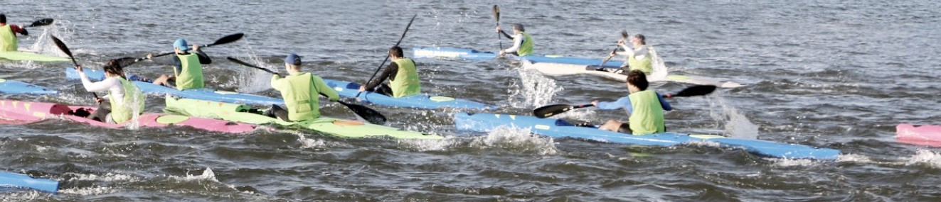The Five2 (single) and Six5 (double) classes give paddlers the ability to participate in all disciplines. The classes are based on a “box rule” with a maximum length and minimum weight the same as an ICF-legal K1 and K2 boats – paddlers may therefore enter sprint competitions or train with sprint squads and enjoy a level playing field. To improve
safety and enjoyment of Paddler-X and Long Distance paddling, particularly on the ocean, all boats must have an open, surfski-style cockpit and leash attachment point.
Aside from these few rules, the World is your oyster. Boats may be produced by any builder – an engaged industry is important to foster innovation and build a thriving, successful class.
12kg minimum weight
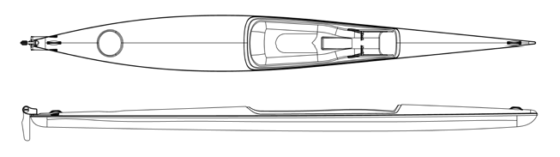

Class rules
  - Open cockpit (surfski style – the boat must be built so that the athlete sits on top, with the hull forming one watertight compartment)
  - Every boat must have a leash attachment point in or near the cockpit
  - There is no minimum or maximum width
18kg minimum weight

The following are permitted:
- A venturi/bailer
- A removable raised seat
- Any design of rudder (internal or over-stern)
- Any mechanism for steering (eg pedals or tiller-bar)
- Any material or method of construction

